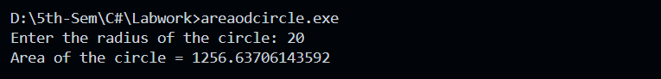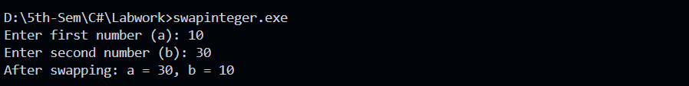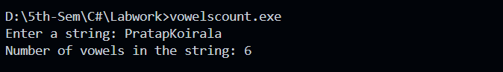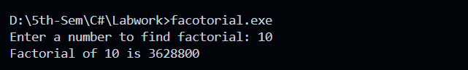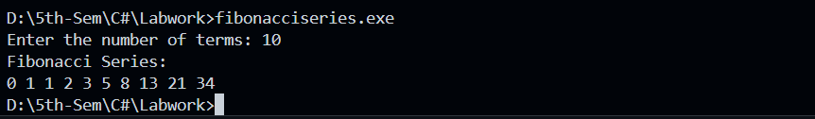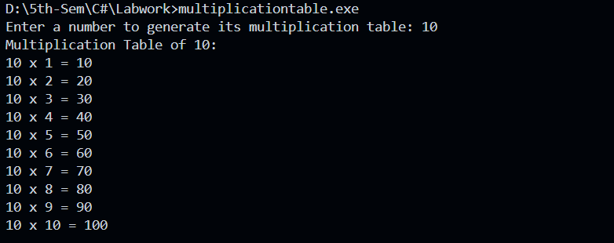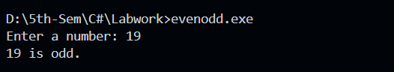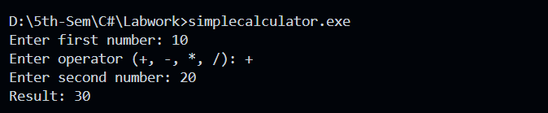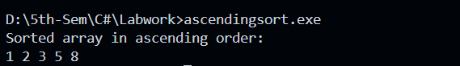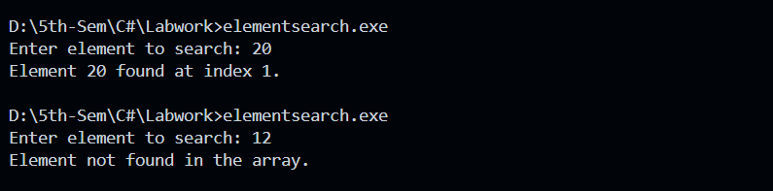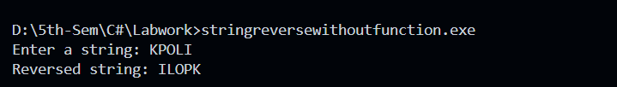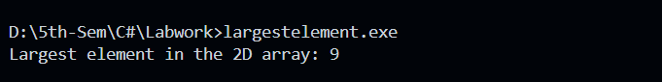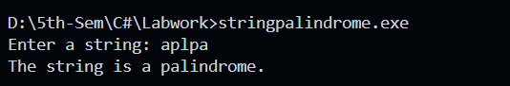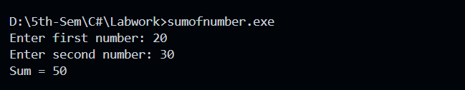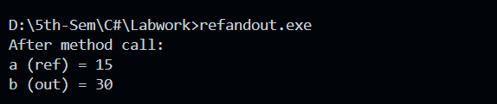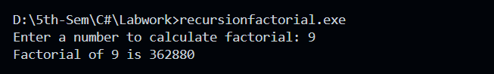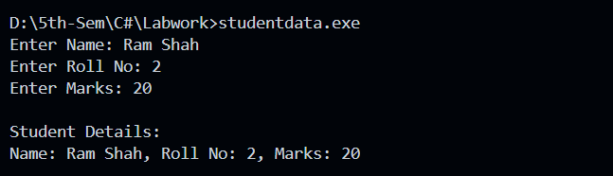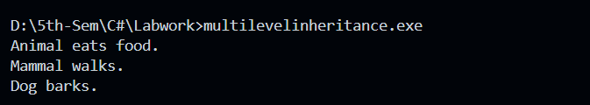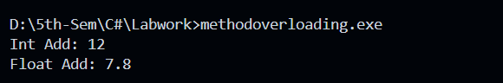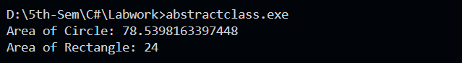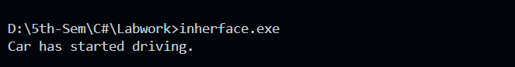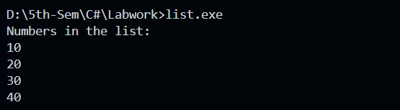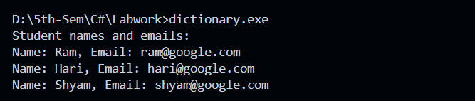

# Index

|  |  |  |  |
| --- | --- | --- | --- |
| S.N. | Name | Date | Remarks |
| 1 | Write a program to calculate the area of a circle using radius as input. |  |  |
| 2 | Create a program that swaps two integers without using a third variable. |
| 3 | Write a program to check whether a given number is prime or not. |
| 4 | Accept a string from the user and count the number of vowels. |
| 5 | Write a program to find the factorial of a number using a for loop. |  |  |
| 6 | Create a program that prints the Fibonacci series up to n terms. |
| 7 | Write a program to generate a multiplication table for a given number. |
| 8 | Accept a number and print whether it is even or odd using if-else. |
| 9 | Use a switch statement to perform a simple calculator (add, sub, mul, div). |
| 10 | Create a program that sorts an array in ascending order. |  |  |
| 11 | Write a program to search an element in an array. |
| 12 | Accept a string and reverse it without using built-in methods. |
| 13 | Write a program to find the largest element in a 2D array. |
| 14 | Accept a string and check if it is a palindrome. |
| 15 | Create a method that returns the sum of two numbers. |  |  |
| 16 | Write a program with a method that uses ref and out parameters. |
| 17 | Create a method to calculate the factorial using recursion. |
| 18 | Create a class Student with fields Name, RollNo, and Marks. Write methods to accept and Display data |  |  |
| 19 | Implement a multilevel inheritance example using own examples. |
| 20 | Demonstrate method overloading with Add(int, int) and Add(float, float). |
| 21 | Create an abstract class Shape with a method Area(), and inherit it in Circle and Rectangle. |
| 22 | Implement an interface IDrive with method Start() and implement it in a class Car. |
| 23 | Use a List<List> to store numbers, add elements and print them. |  |  |
| 24 | Use a Dictionary<String, String>to store student names and emails. |